

**Generic reflash and drive working introduction**

Contents

1.Reflash environment preparation 3

2.Reflash 6

3.Drive and check SW version with different ECU addresses 7

3.1 Switch ECU address 7

3.2 Drive 8

3.3 Check SW version 9

# 1.Reflash environment preparation

1. To reflash, you need to prepare:
   1. Pump
   2. Power supply
   3. Wire harness with V+, V-, CAN_H, CAN_L
   4. CAN converter
   5. PC with Mahle tool

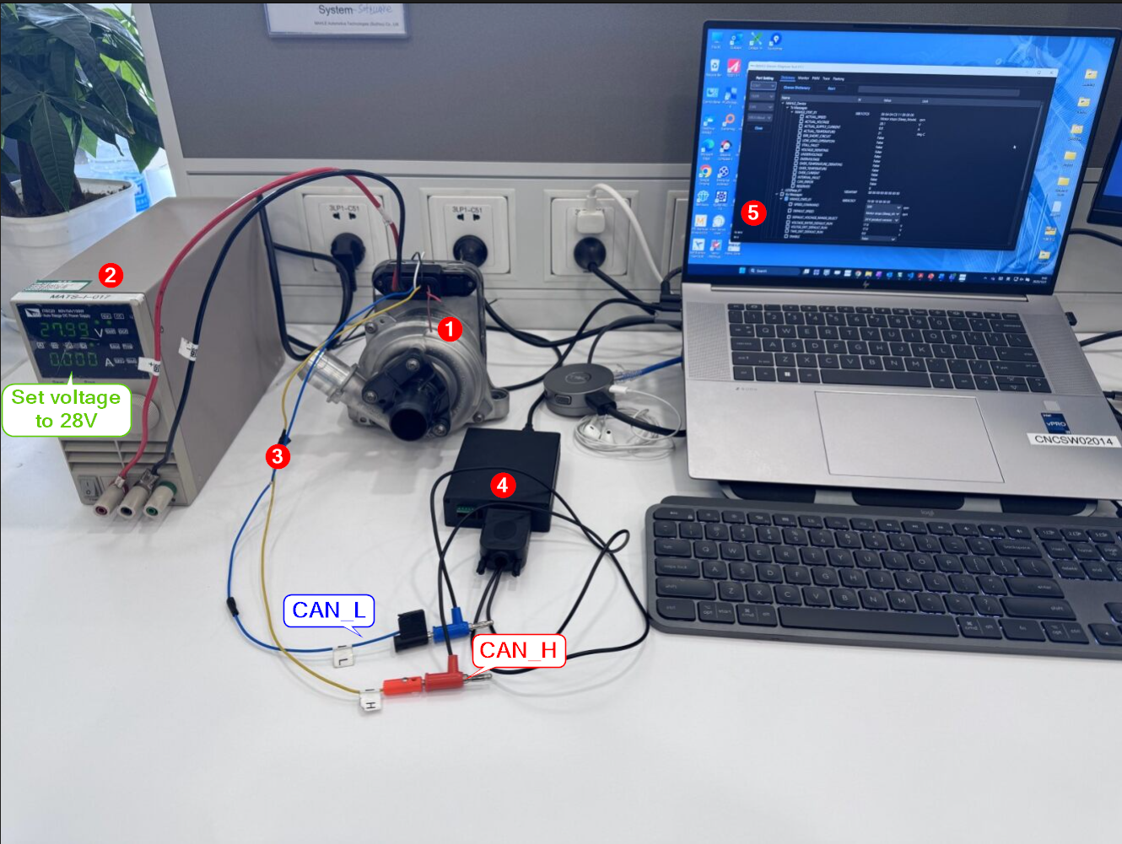

1. Wire connection layout.

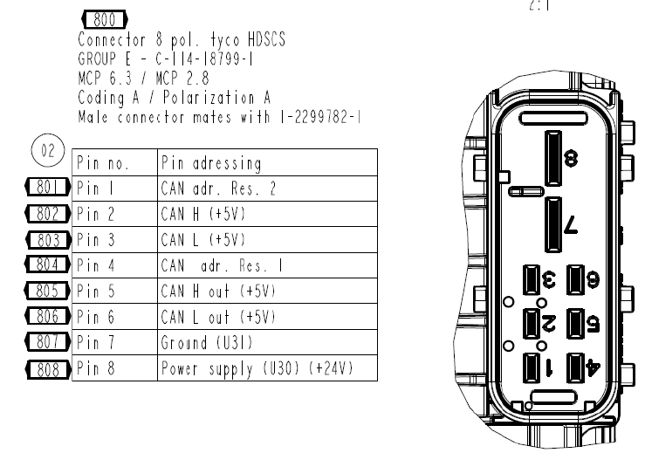

1. Open device manager, connect the CAN converter to see which port the converter is using. (On my computer is 7)

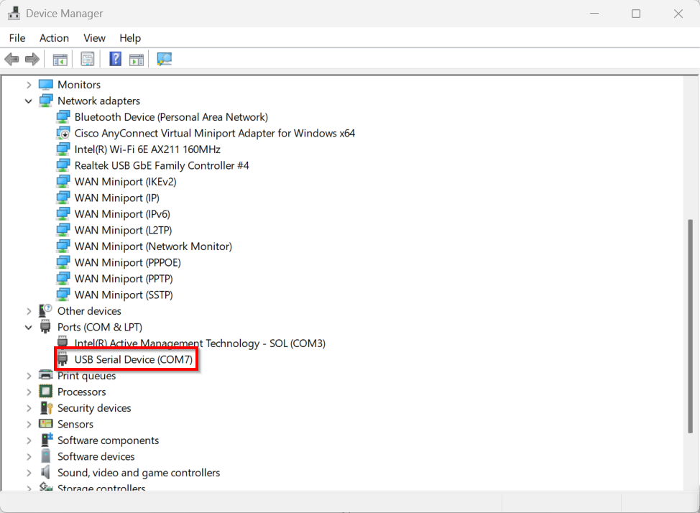

1. Set the voltage to 28V and power on.

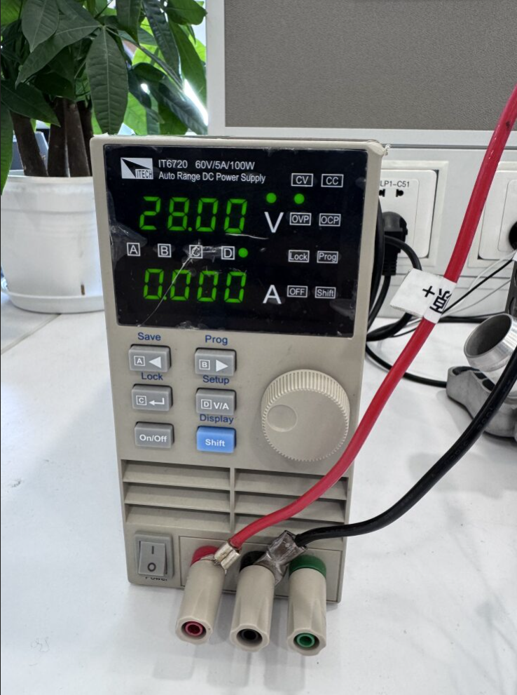

# 2.Reflash

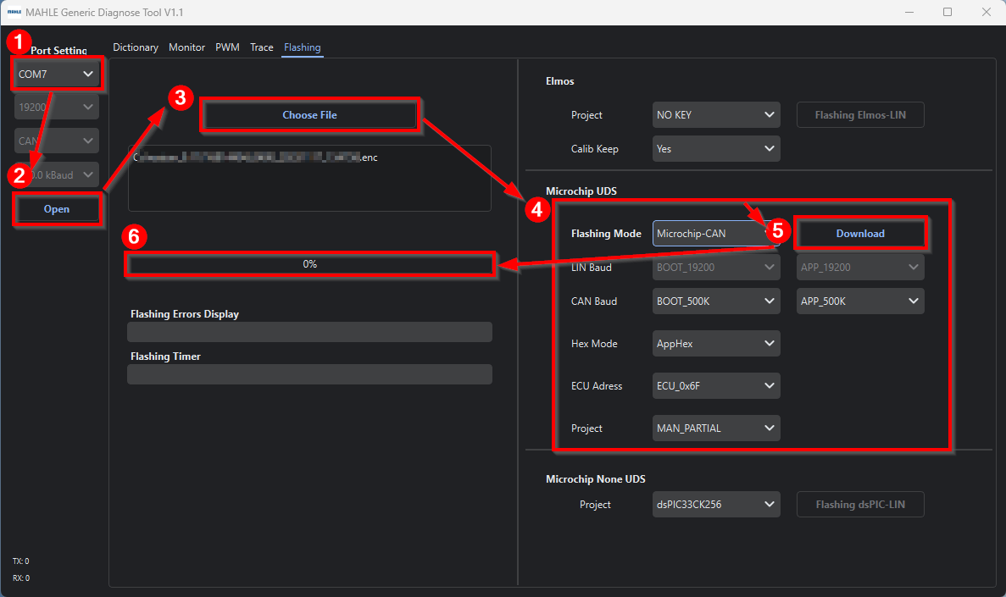

1. Select the port of computer which connects to the converter.
2. Click “Open” button.
3. Click “Choose file” and choose .enc file (software) which need to be reflashed
4. Select “Microchip-CAN” set the value as showed
5. Click “Download”
6. Wait until the process goes to 100%. (Re-click “Download” if reflash unsuccessfully)

# 3.Drive and check SW version with different ECU addresses



## Switch ECU address

1. Click “Choose Dictionary” and choose “Mahle_Generic_Can_v1_3_for_MADD.dbc”

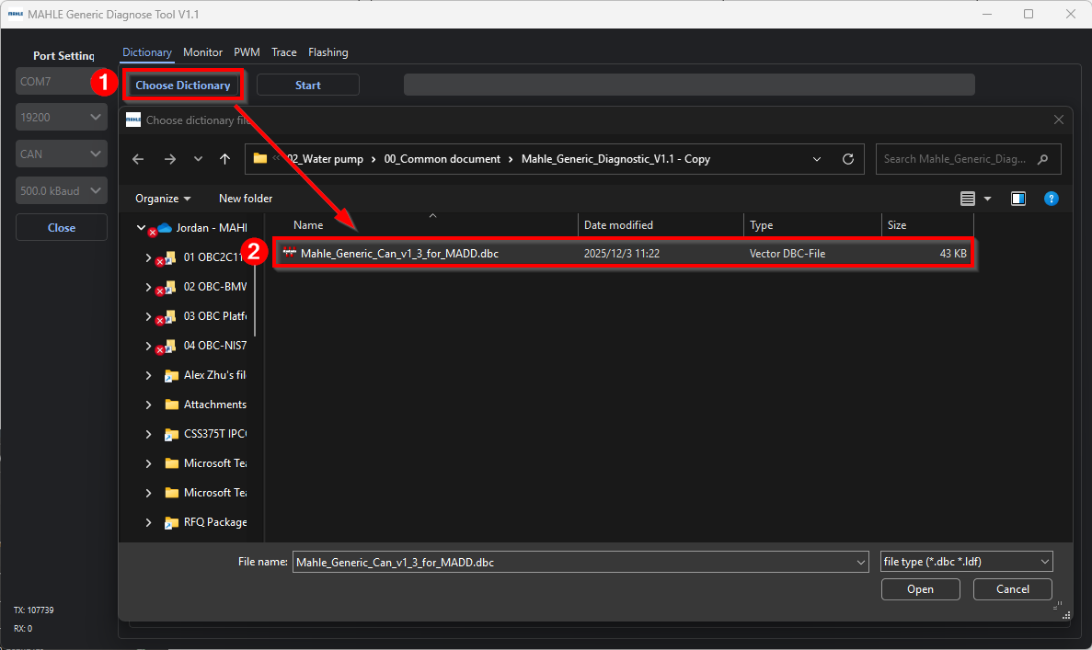

1. To switch between MAHLE_Device (ECU address 0x6F) and MAHLE_Device_2 (ECU address 0x66), connect(0x66) or disconnect(0x6F) pin1 and pin4.

(connect/disconnect before clicking “Start” button)

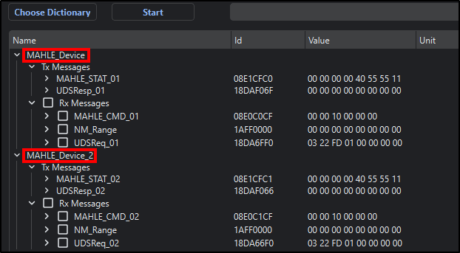

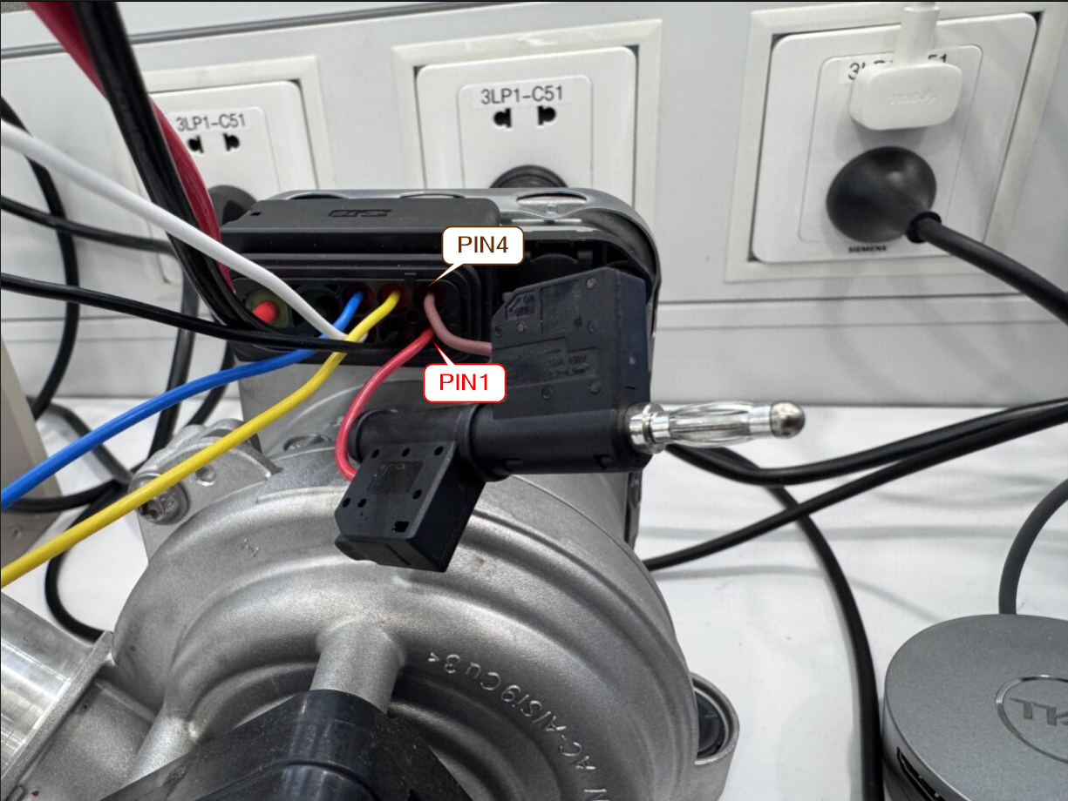

## Drive

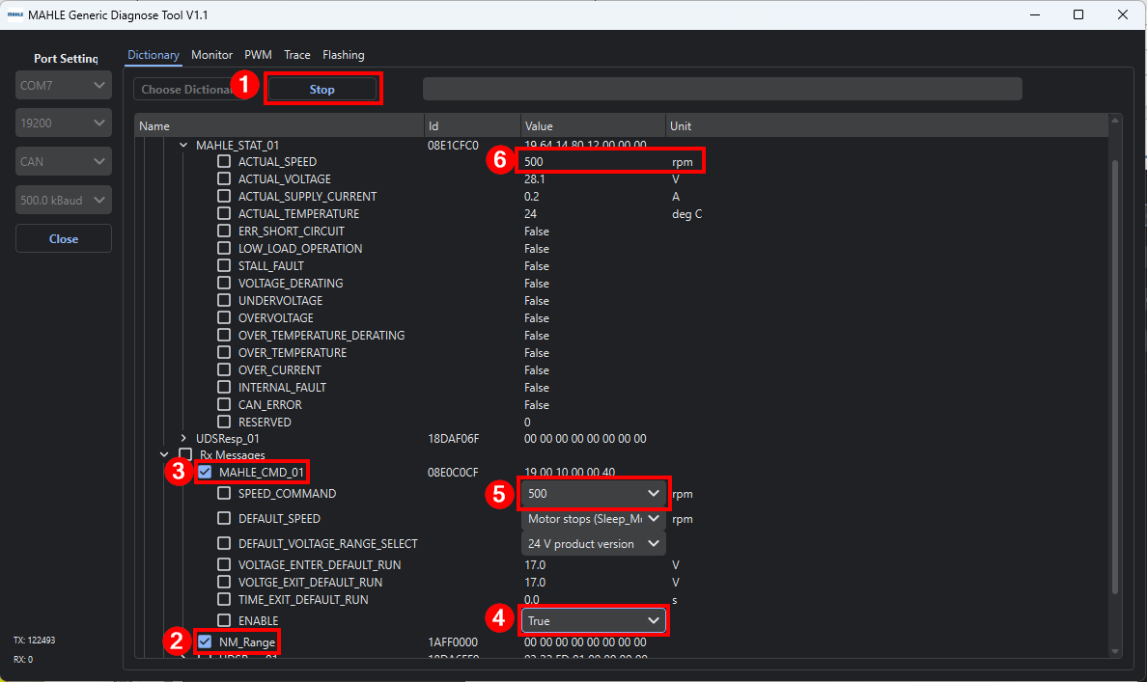

1. Click “Start” button.
2. Check “NM_Range” option.
3. Check “MAHLE_CMD” option.
4. Set “ENABLE” to “True”.
5. Set “SPEED_COMMAND”.
6. Check if “ACTUAL_SPEED” matches “SPEED_COMMAND”.

## Check SW version

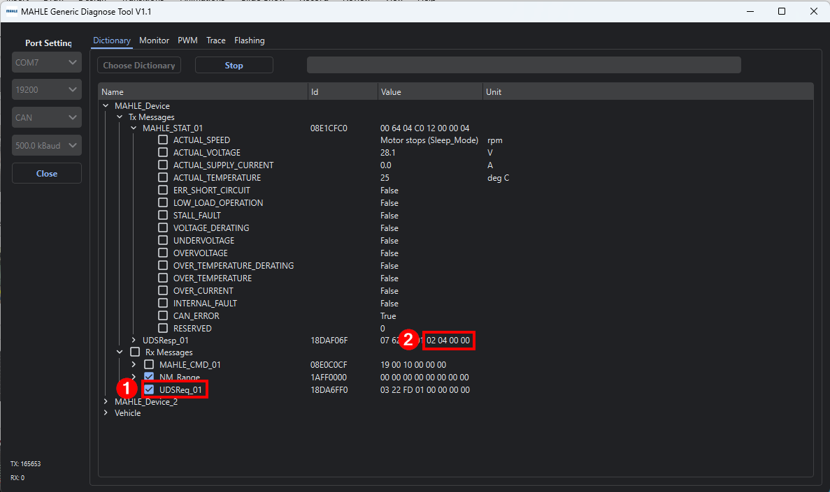

1. Check “UDSReq_01” option.
2. SW version will be shown at “UDSResp”. (Last four numbers)